**Institute of Technology Tralee**

**Ordinary/Honours BSc. in Computing with Specialism (Group D) - Year 1**

**Continuous Assessment #1**

**Date: 6/11/12**

**Time: 3 – 5 p.m.**

**Introduction to Programming**

**Instructions:** Attempt the following question. You should use the Just BASIC IDE for coding. When you are finished you must print out your code for correction.

**________________________________________________________**

**Q1.**

A Just BASIC program is required that first of all reads in the x and y co-ordinates of 2 points. The first point is to be the **upper-left point** of a rectangle and the second is to be the **bottom-right point** of the same rectangle. You can take it here that all co-ordinates will be **numeric values**.

When the values of the x and y coordinates of the bottom-right point are entered they must be **validated** against the upper-left x and y co-ordinates to ensure that the x co-ordinate of the bottom-right point **exceeds** the value of the x co-ordinate of the upper-left point and that the y co-ordinate of the bottom-right point **is lower than** the value of the y co-ordinate of the upper-left point.

If either of the bottom-right co-ordinates are invalid then a suitable warning message should be issued and the program should immediately exit.

However, if both co-ordinates are valid then the program should then determine whether the rectangle is a square. The rectangle will be a square only if the difference between the bottom right x co-ordinate and the upper-left x co-ordinate equals the difference between the upper-left y co-ordinate and the bottom-right y co-ordinate.

Using the test values as indicated in the screen shots below, the program should give you **exactly** the following output when it runs, including banners, blank lines etc.

Also note that there will be a few marks awarded for the use of **meaningful variable names**, having a **meaningful comment at the top of the program** and for **proper indentation** in the coding of the program.

**Sample Screen Shots**

**In this run the bottom-right x-coordinate is invalid**

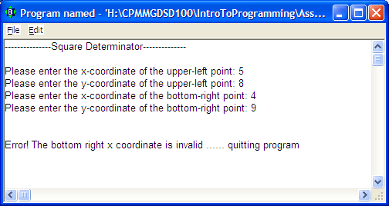

**In this run the bottom-right y-coordinate is invalid**

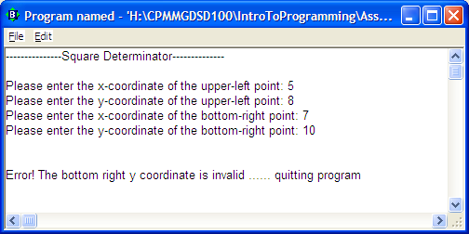

**In this run the points are valid but the rectangle they describe is not a square**

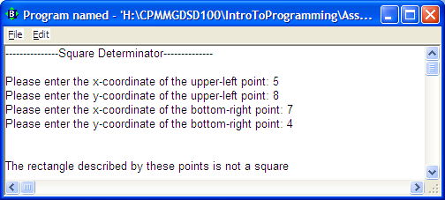

**In this run the points are valid and the rectangle they describe is a square**

